Geometric Nonlinear Analysis of a Cantilever Beam with BREP elements

Objective:
To validate the Geometric Nonlinear Analysis of the shell element with different types of patches in the Kratos IGA application.
- Model Description:
The reference model is a cantilever beam subjected to end shear force, taken from “Popular Benchmark problems for geometric nonlinear analysis of shell” by K.Y. Sze et al. The tip model is given in Fig. 1, and displacement results are shown in Fig. 2. Please refer to the paper for further.
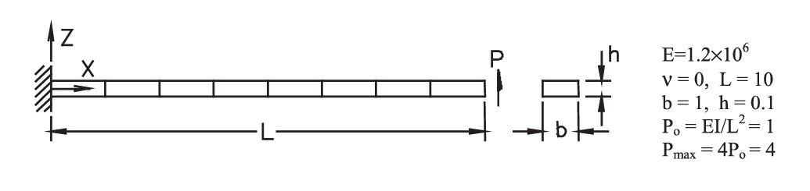
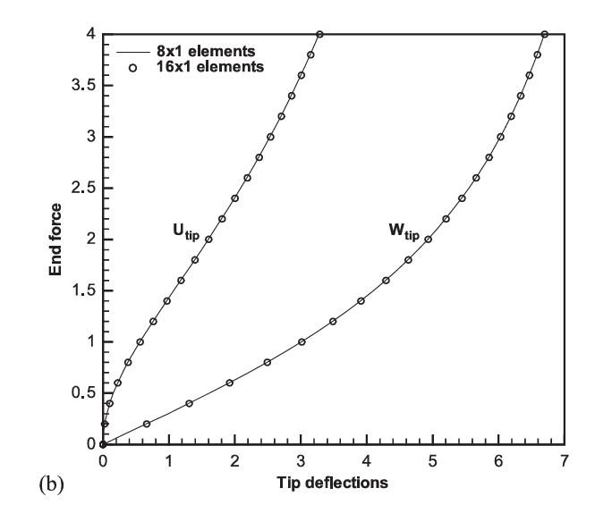
Fig 1: Model
Fig 2: Reference results – Tip Displacement

2. Study:
The following types of patches were studied.
- Single Patch
- Matching Patches
- Non-Matching Patches
- Straight Trimmed Patches
- Curved Trimmed Patches

  - Single Patch
In this model, the entire cantilever beam was modelled with a single-patch IGA shell element.

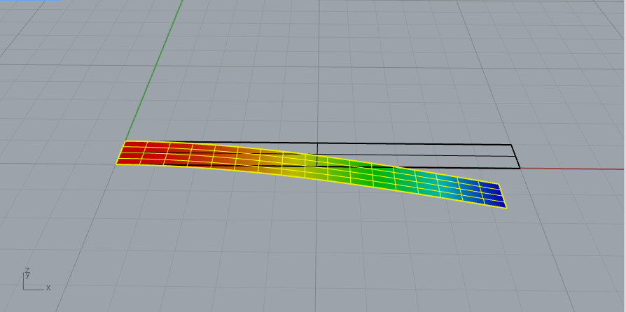
No of control points in X direction = 3
No of control points in Y direction = 16

The peak load (4 units) was reached by iteratively increasing the load by 10 load steps (step size 4/10 = 0.4). In each load step, the solution converged in 3 iterations. Also, if the peak load is selected in single load step, the solver converged within 10 iterations.

  - Matching Patches
In this model, the entire cantilever beam was modelled with two patches of IGA shell elements. It was ensured that the degree of the curve and the number of control points on the connecting edge match

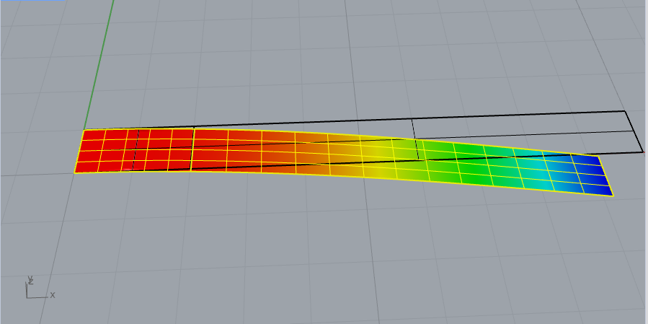
No of control points in X direction = 4,12
No of control points in Y direction = 3,3

The peak load (4 units) was reached by iteratively increasing the load by 10 load steps. In each load step, the solution converged in 6 to 13 iterations. Also, if the peak load is selected in single load step, the solver converged in 17 iterations

  - Non-Matching patches
In this model, the entire cantilever beam was modelled with two patches of IGA shell elements. But, when compared to the previous model, here the number of control points on the connecting edge is not matched.

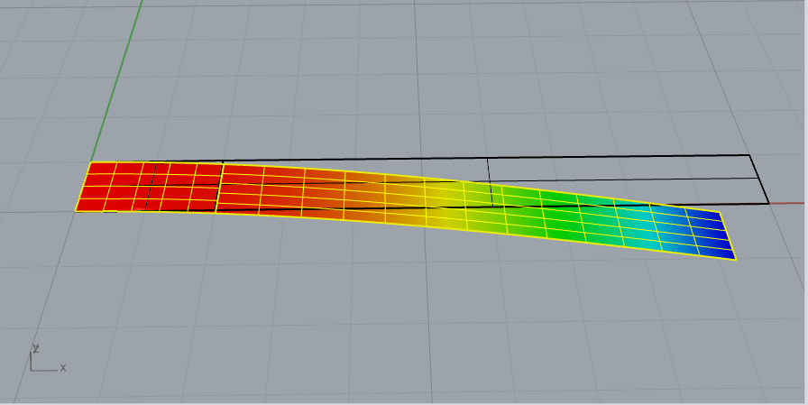

No of control points in X direction = 4,12
No of control points in Y direction = 3,4

The peak load (4 units) was reached by iteratively increasing the load by 10 load steps. In each load step, the solution converged in 6 to 13 iterations. Also, if the peak load is selected in single load step, the solver converged in 17 iterations

  - Straight Trimmed Patches
In this model, the entire cantilever beam was modelled with two patches of IGA shell elements. The two IGA elements were trimmed IGA elements. The trimming curve is a straight line

2.4.1 Match Trimmed Patches

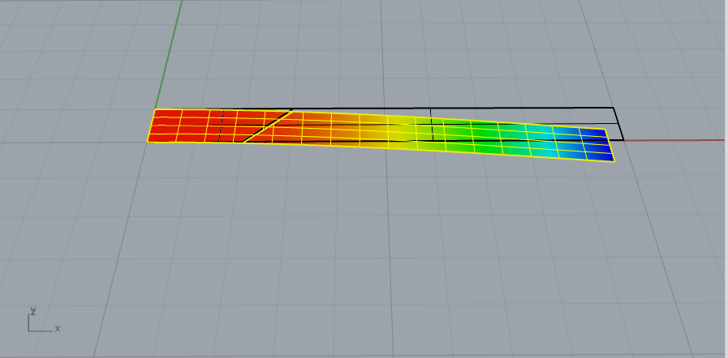

No of control points in X direction = 4,12
No of control points in Y direction = 4,4

For this model, with a load step size of 0.4, the solver converges up to a load value of 1.6 units. After that, it did not converge. However, with a reduced load step size of 0.2, the solver also converged for the peak load value. If the number of control points in Y direction is changed to 3,3, then solver did not converge for both load step size.

2.4.2 Non-Match Trimmed Patches

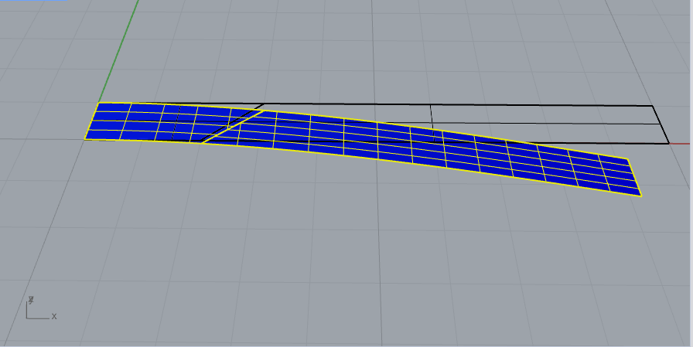

No of control points in X direction = 4,12
No of control points in Y direction = 3,4

For this model, with a load step size of 0.4, the solver converges up to a load value of 0.8 units. After that, it did not converge. However, with a reduced load step size of 0.2, the solver also converged for the peak load value. For both the previous match and this non-match, if the starting load is is kept at 0.1, the solver did not converge.

  - Curved Trimmed Patches
In this model, the entire cantilever beam was modelled with two patches of IGA shell elements. The two IGA elements were trimmed IGA elements. The trimming curve is a curve.

No of control points in X direction = 4, 12
No of control points in Y direction = 4, 4

No of control points in X direction = 12, 4
No of control points in Y direction = 3, 4

Unable to achieve convergence after a load value of 0.4, even with the low load step value of 0.04 for both the match and the non-match patch.

